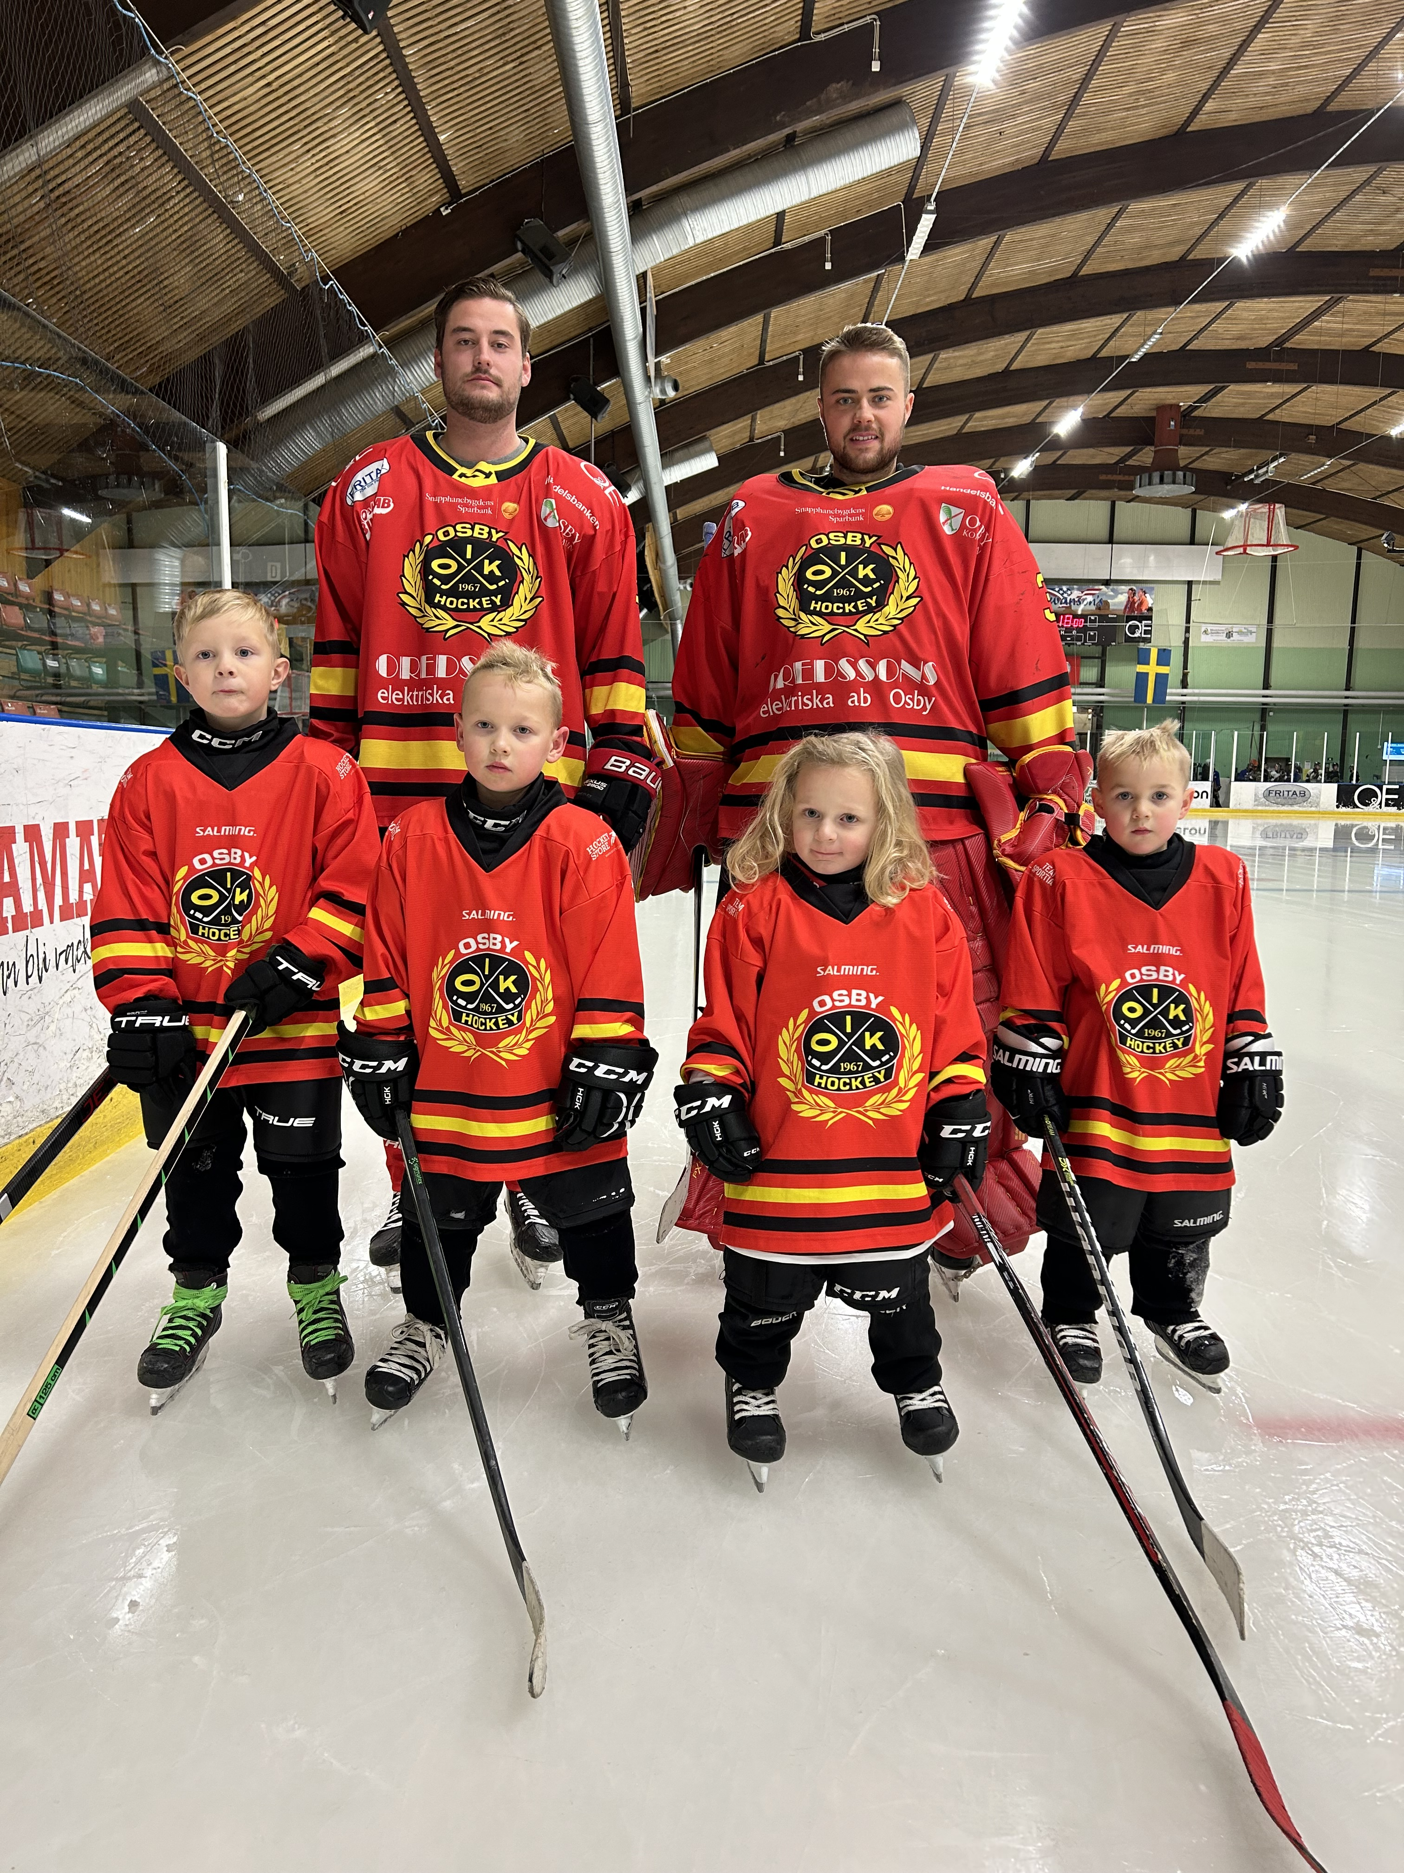


Innehållsförteckning OIK-ringen

Ingredienser/100g: Griskött, grishjärta, nötkött, späck, salt , socker, potatismjöl, potatisflingor, kryddor, konjaksarom, antioxidationsmedel E301, konserveringsmedel E250.

Näringsvärde/100g: Energivärde: 1466KJ (350 kcal).
Fett: 30g – varav mättat fett 11,1g.
Kolhydrat: 4,5g – varav sockerarter: 1,9g.
Protein: 16,4g. Salt: 2,9g
Köttmängd: 74%.
Hållbarhet: Kylvara 45 dagar.

Går bra att frysa!

BESTÄLLNINGSLISTA
OIK-RINGEN

1 kg rökt korv för 140:-/st

Sista beställningsdag 28 oktober!

Namn Antal
__________________________________________ ______
__________________________________________ ______
__________________________________________ ______
__________________________________________ ______
__________________________________________ ______
__________________________________________ ______
__________________________________________ ______
__________________________________________ ______
__________________________________________ ______
__________________________________________ ______
__________________________________________ ______
__________________________________________ ______
__________________________________________ ______
__________________________________________ ______
__________________________________________ ______
__________________________________________ ______
__________________________________________ ______
__________________________________________ ______
__________________________________________ ______
__________________________________________ ______
__________________________________________ ______
__________________________________________ ______
__________________________________________ ______
__________________________________________ ______
__________________________________________ ______
__________________________________________ ______
__________________________________________ ______
__________________________________________ ______

