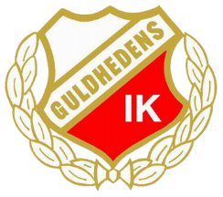
Guldhedens IK PF14 Team Rules
Before Training
- I will say hello to the coaches, my teammates, every member of the club, and parents I meet.
- I will not eat candy or chips before training.
- I will be on time in the locker room before 17:10.
- I will wait in the locker room for the coaches.
- I will have appropriate equipment on:
  - Football shoes tied
  - Protection on
  - Water prepared in a bottle for the pitch
- If I cannot come, I will inform the coaches. If I am late, I will also inform the coaches.
At 17:15
- After the coaches’ welcome speech, I will go onto the pitch together with my teammates.
- I will help with the equipment.
During Training
- I will be positive.
- I will smile and have fun
- I will listen to the coaches.
- I will do the exercises seriously.
- I will not disturb the training.
- I will raise my hand to talk.
- I will let others speak and listen to my teammates.
- I will not use bad language.
- I will respect my teammates and coaches.
- During training games, I will respect the referees’ decisions. It is just training, and we are all on the same team.
After Training
- I will help take the equipment back to the locker room.
- I will say goodbye to the coaches, my teammates, every member of the club, and parents I meet.
I agree with the team rules and will do my best to follow them. I accept that the coaches will build the team that will play the games and cups with the players who follow these rules and respect the team spirit.
Signature:
Player Name: ______________________

Parent Name: ______________________

